CASE STUDY
Netflix Movies and
TV Shows Analysis
A Python-based exploratory data analysis

Submitted by | Muskan gupta
Roll Number | 25BCD10069
Course / Section | BCA(DAT SCIENCE)
Submitted to | MRS. PREETI

Project files: netflix_titles.csv, projectmini.py, project_outputs/

1. Problem Statement
Streaming platforms contain large catalogues of movies and television shows. Looking at raw records alone makes it difficult to see how the catalogue is distributed by content type, genre, country, rating, release year and duration. This case study uses the Netflix titles CSV dataset to explore those patterns with Python.
The main objective is to load and clean the dataset, summarize important numerical and categorical fields, visualize useful patterns, and communicate the findings in a clear way. The analysis is descriptive: it explains patterns in the supplied dataset and does not measure Netflix viewership, popularity or business performance.

2. Dataset Description
The project uses the file netflix_titles.csv. The dataset contains information about Netflix titles, including their type, title, director, cast, country, date added, release year, rating, duration, genre/category labels and description. In the commonly distributed version used for this project, the dataset has 8,807 records and 12 columns; the content-type chart also totals 8,807 titles (6,131 movies and 2,676 TV shows).
Field / group | Example data type | Purpose in this analysis
type, title | Text / categorical | Compare movies and TV shows; identify titles
director, cast, country | Text | Describe people and countries associated with titles
date_added | Date after conversion | Count titles added by year
release_year | Numeric year | Study release-year distribution and statistics
rating, duration | Text, then extracted numeric values where needed | Compare ratings; analyze movie minutes and TV seasons
listed_in, description | Text | Explore genres and provide title descriptions
The CSV is read with pandas.read_csv(). The script prints the first five rows, the dataset shape, column information, missing-value counts and duplicate-row count before cleaning.

3. Data Cleaning Using Pandas

3.1 Missing values
The script checks missing values with df.isnull().sum(). Missing entries in director, cast, country, rating, duration, listed_in and description are filled with the label “Unknown”. This keeps the records available for most categorical summaries while making the absence of information visible.

3.2 Duplicate records
Duplicate rows are counted with df.duplicated().sum() and removed with df.drop_duplicates().copy(). This avoids counting identical rows more than once.

3.3 Incorrect data types
The date_added column is converted to a datetime format with errors='coerce', and release_year is converted to a numeric type. Invalid values become missing values rather than stopping the program. Movie duration and TV season counts are extracted from the duration text and converted to numbers for the relevant analyses.

3.4 Inconsistent values
Leading and trailing spaces are removed from text columns. The script also excludes “Unknown” genre and country values before counting those categories. These steps make category counts more consistent, although a deeper validation of spelling variations and unusual values could be added in a future version.

4. Data Analysis Using NumPy & Pandas

4.1 Mean, median and standard deviation
NumPy is used on the non-missing release_year values to calculate the mean, median and standard deviation, as well as the earliest and latest release years. These statistics describe the distribution of release years; they do not indicate how old or popular a title is today.

4.2 Grouping and aggregation
Pandas value_counts() is used to count content types, ratings, genres, countries, TV seasons and years added. For multi-label genre and country fields, split() and explode() place each listed category into a separate row before counting. A title can therefore contribute to more than one genre or country category.

4.3 Sorting and filtering
The script filters movies and TV shows separately, removes unknown categories from genre/country summaries, selects the top ten genres, ratings and countries, and sorts year-based counts in chronological order. Movie duration is analyzed only for records with a valid extracted numeric duration.

4.4 Correlation
A correlation matrix is calculated between release_year and year_added (the year extracted from date_added). The supplied heatmap shows a correlation of approximately 0.11, which is a weak positive association. Correlation does not establish that one variable causes the other, and the result depends on the available records.

5. Data Visualization
Matplotlib is used to create figures and save them as PNG files; Seaborn is used for several bar charts, a histogram and the correlation heatmap. The following figures reproduce the main patterns visible in the supplied project outputs. The code also generates release-year trends, top-country counts and a movie-duration histogram.
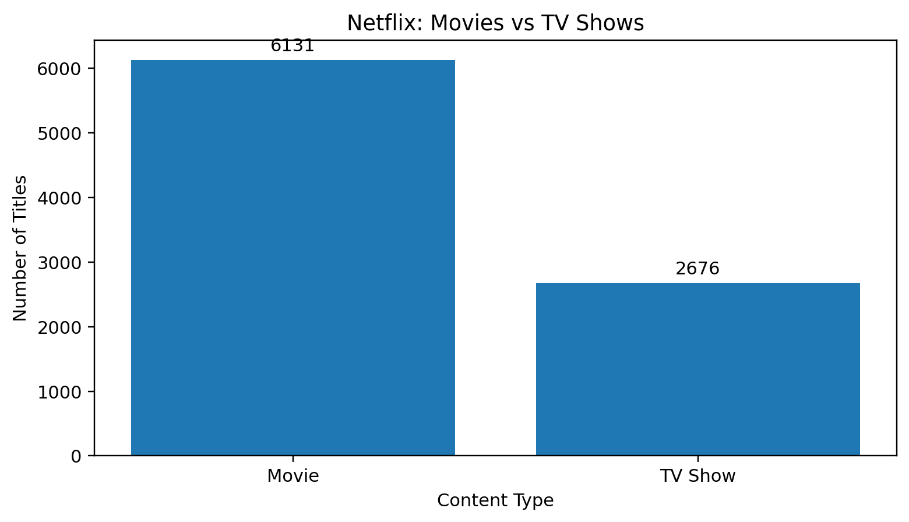
Figure 1. Distribution of movies and TV shows.
Interpretation: Movies account for 6,131 titles and TV shows for 2,676 titles in the displayed dataset, so movies form the larger content group.
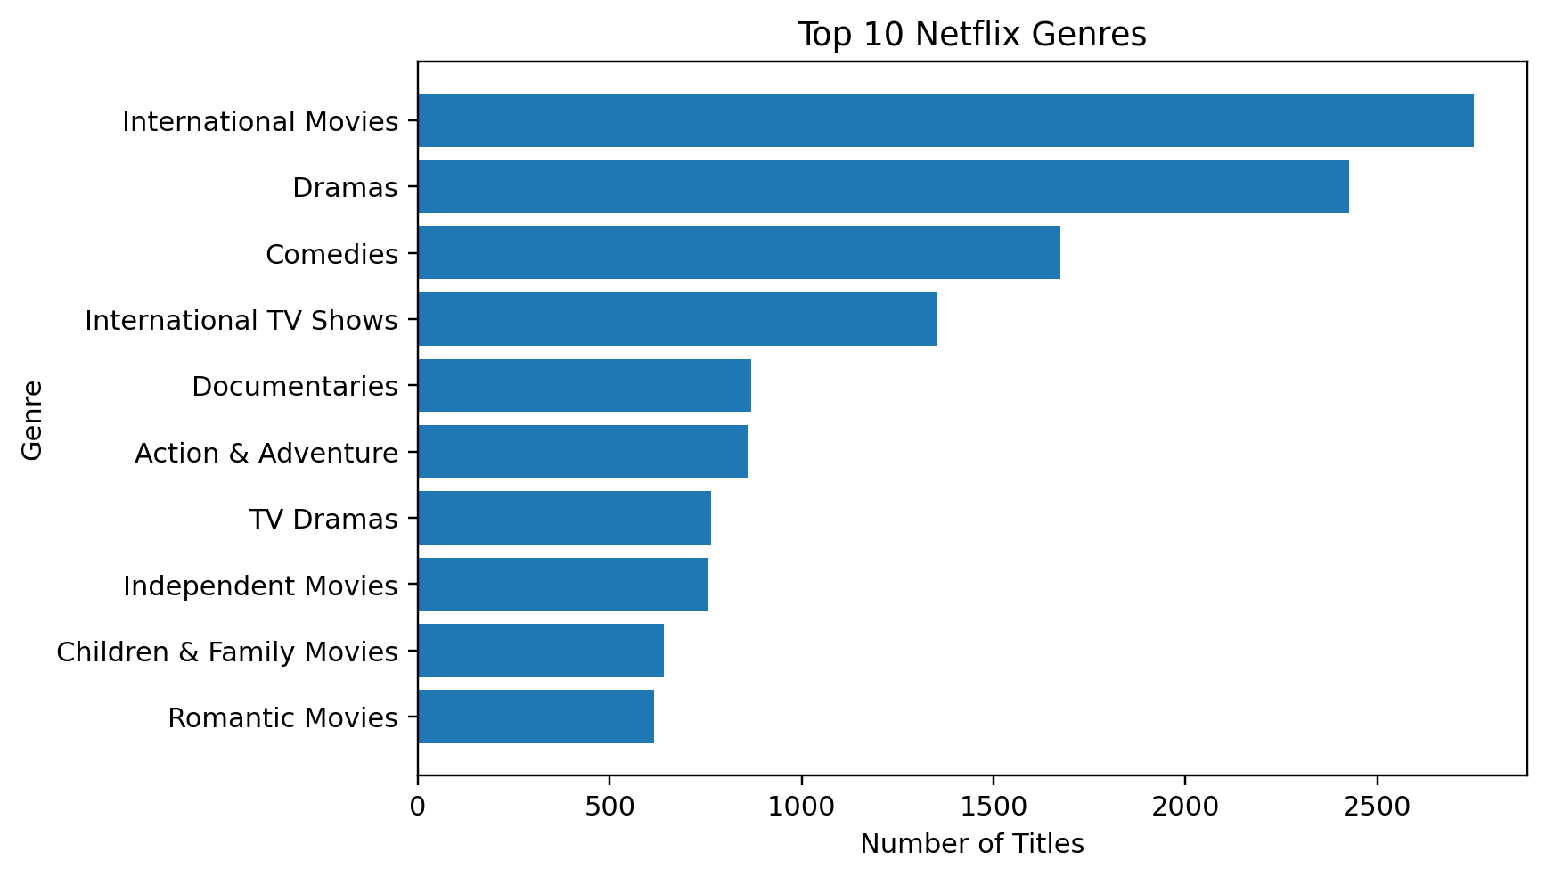
Figure 2. Top ten genre labels shown in the supplied output.
Interpretation: International Movies is the leading category in the supplied top-ten genre chart, followed by Dramas and Comedies. Genre counts may overlap because one title can have multiple labels.
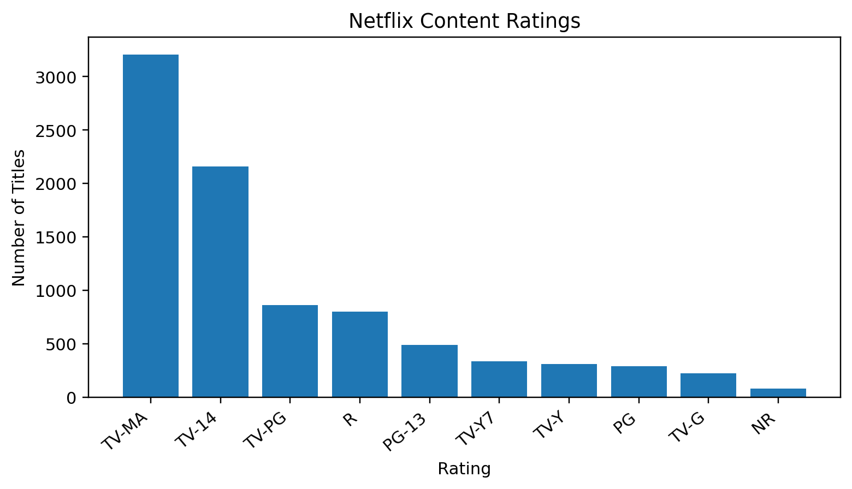
Figure 3. Most frequent content-rating categories in the supplied output.
Interpretation: TV-MA is the most frequent displayed rating, followed by TV-14. Ratings describe content suitability rather than audience size or quality.
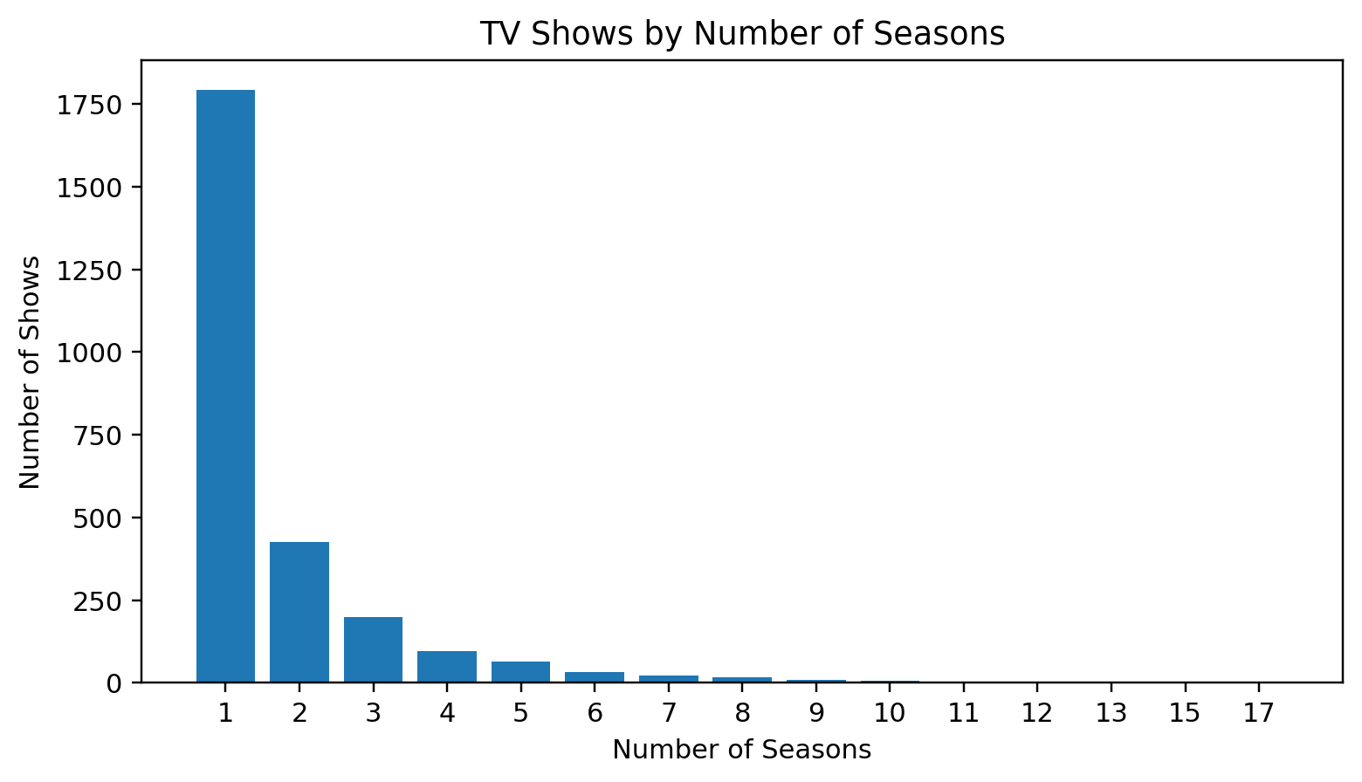
Figure 4. TV shows grouped by number of seasons.
Interpretation: One-season shows form the largest group in the supplied chart, and the number of shows generally decreases as the season count increases.
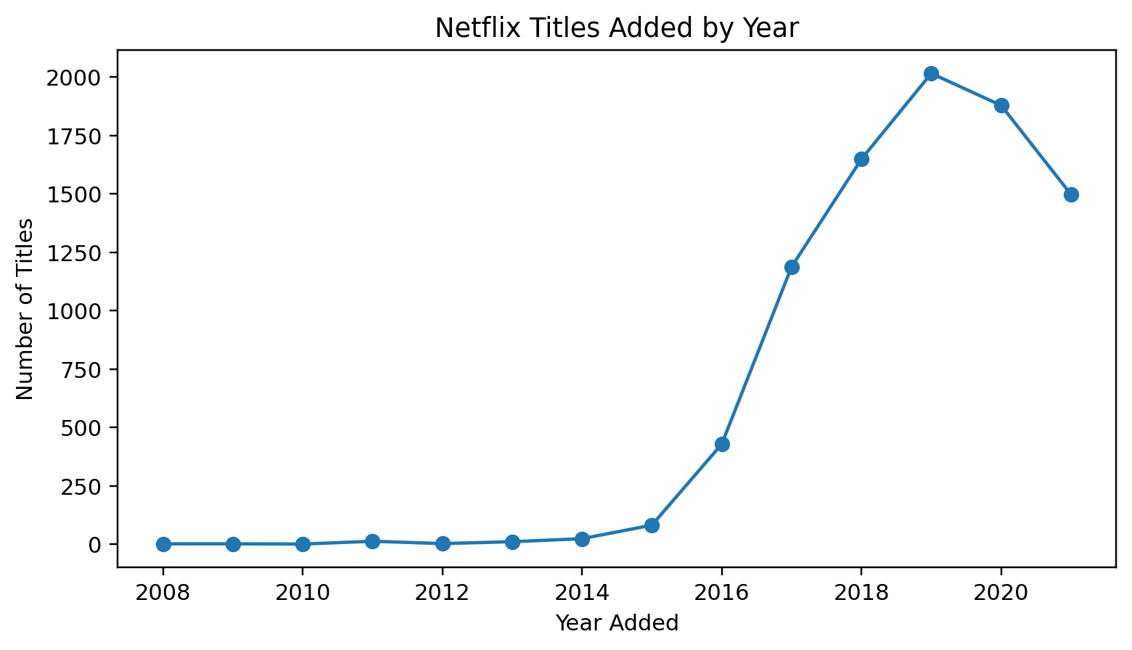
Figure 5. Titles added to Netflix by year, as shown in the supplied output.
Interpretation: The displayed series rises strongly in the second half of the 2010s and peaks around 2019 before declining in later years. This is a count of titles added to the dataset, not a measure of viewership.
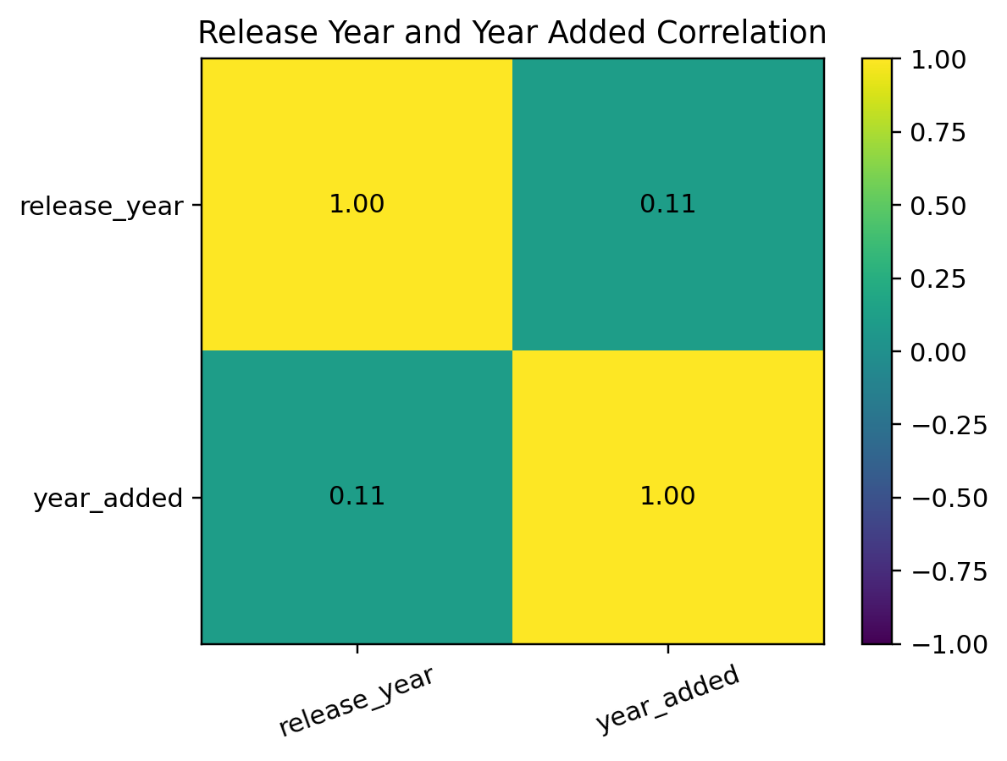
Figure 6. Correlation heatmap for release year and year added.
Interpretation: The off-diagonal correlation is approximately 0.11, indicating a weak positive linear association between release year and year added in the supplied data.

Other visualizations produced by the script
The Python script also saves 02_release_trends.png (titles by release year), 05_countries.png (top countries) and 06_movie_durations.png (movie-duration histogram). These should remain in the project_outputs folder alongside the figures reproduced above. The current script does not create pie charts, scatter plots, box plots, violin plots, count plots or pair plots; those are possible extensions, not completed outputs.

6. Findings
- Movies are more numerous than TV shows in the supplied content-type chart: 6,131 compared with 2,676.
- International Movies is the leading genre label in the supplied top-ten genre chart.
- TV-MA is the most frequent displayed content rating, followed by TV-14.
- TV shows with one season form the largest season-count group in the supplied output.
- The number of titles added per year rises substantially during the second half of the 2010s and peaks around 2019 in the displayed series.
- The correlation between release year and year added is weak and positive at approximately 0.11; it should not be treated as a causal relationship.
- Genre and country counts can overlap because a single title may list multiple genres or countries.
- Cleaning missing values, removing duplicate rows and converting date/numeric fields are important for producing more dependable summaries.

7. Conclusion
This case study applies a basic data-analysis workflow to a Netflix titles dataset. Pandas supports loading, inspecting, cleaning, filtering and grouping the data; NumPy provides numerical summaries; and Matplotlib and Seaborn turn selected results into charts. The outputs show a larger number of movies than TV shows, International Movies as the leading displayed genre label, TV-MA as the most frequent displayed rating, and one-season shows as the largest season group.
The results are descriptive and should be interpreted within the limits of the dataset. The file describes catalogue metadata rather than viewing figures, so the analysis cannot determine which titles were watched most or whether a title was successful. Future work could add an interactive dashboard, validate unusual entries, and include further visualizations or a compact table of all exact statistical results.

References
- Netflix titles dataset supplied with the project: netflix_titles.csv.
- Pandas documentation: https://pandas.pydata.org/docs/
- NumPy documentation: https://numpy.org/doc/
- Matplotlib documentation: https://matplotlib.org/stable/
- Seaborn documentation: https://seaborn.pydata.org/

Appendix: Project files
projectmini.py — Python analysis script
netflix_titles.csv — source dataset
project_outputs/ — saved charts (PNG files)
case_study/ — folder for this case-study Word document

